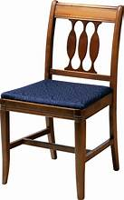**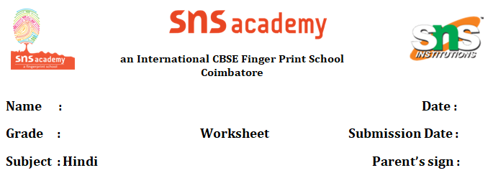 Names of household items.**

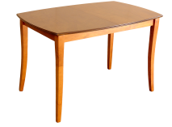**1.मेज-maej -table 2.कुर्सी-kursi-chair**

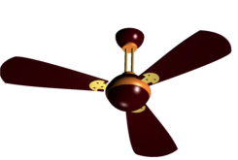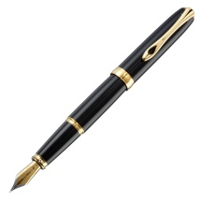

**3.कलम-kalam-pen 4.पंखा-pankha-fan**

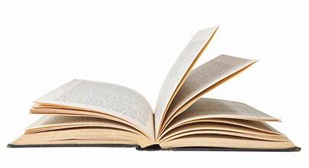

**5.किताब-kithaab-book**

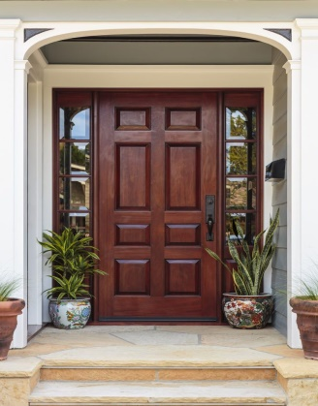

**6.दरवाजा-dharvaajaa-door**

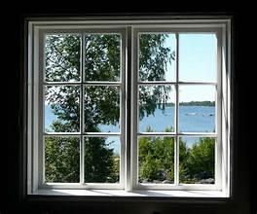

**7.खिड़की-khidaki-window**

8. चश्मा- chashma-spectacle

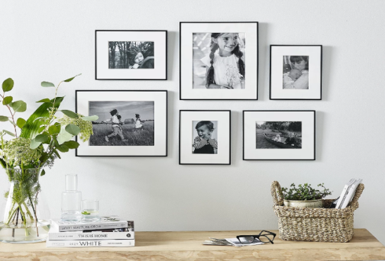

9. दीवार-deevaar-wall

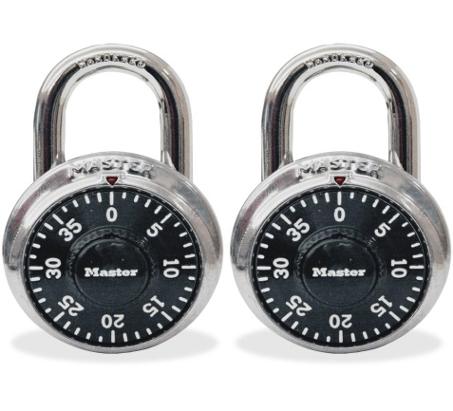

10. ताला-taalaa-lock

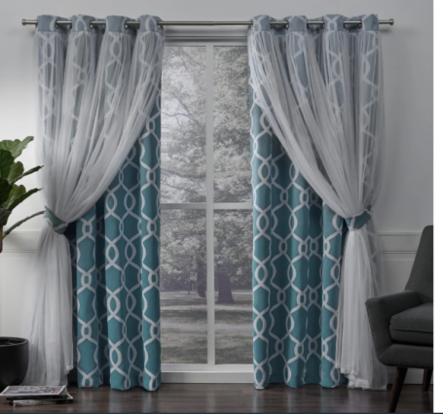

11.परदा-pardha-curtain

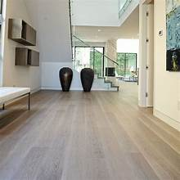

12.जमीन-jameen-floor

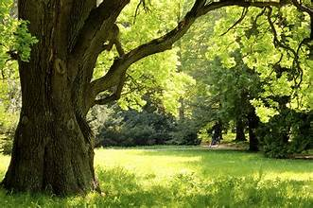13.पेड़-paed-tree

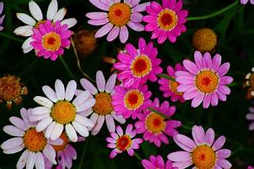

14.फ़ूल-phool-flower

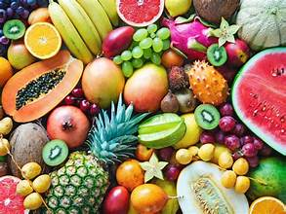

15. फ़ल-phal-fruits

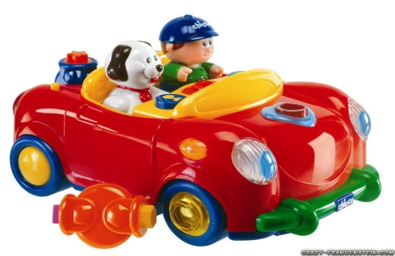

16.खिलौना-khilouna -toy

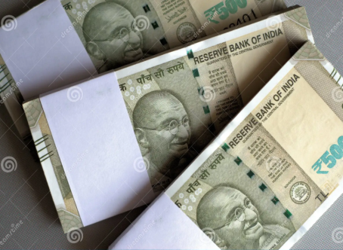

17.रुपया-rupaya-rupee

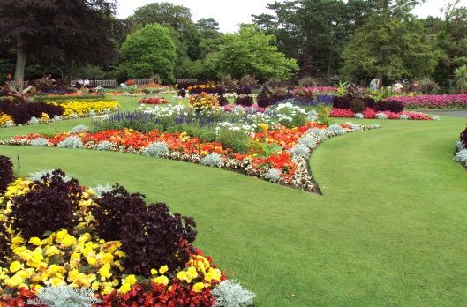

18.बगीचा-bageechaa-garden

R. Pushpa